**VV8:Create a Virtual Hard Disk and allocate the storage using VM ware Workstation**

STEP1:Before hard disk inserting

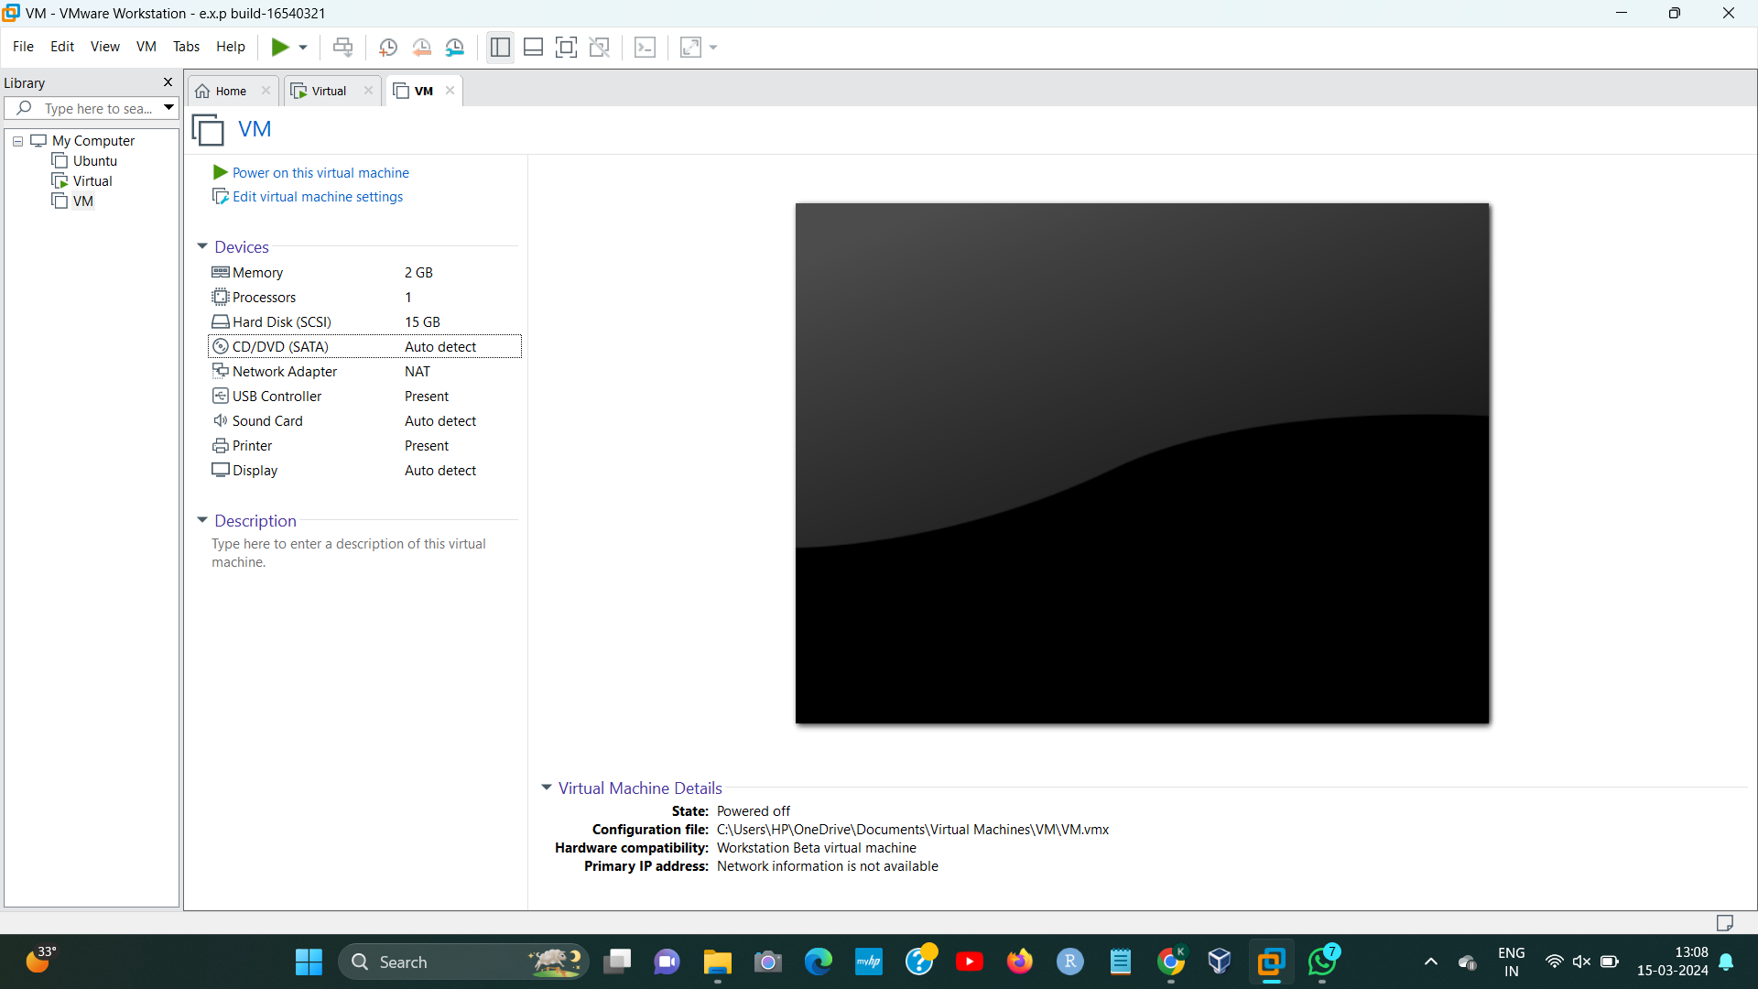

STEP2:After inserting Hard disk

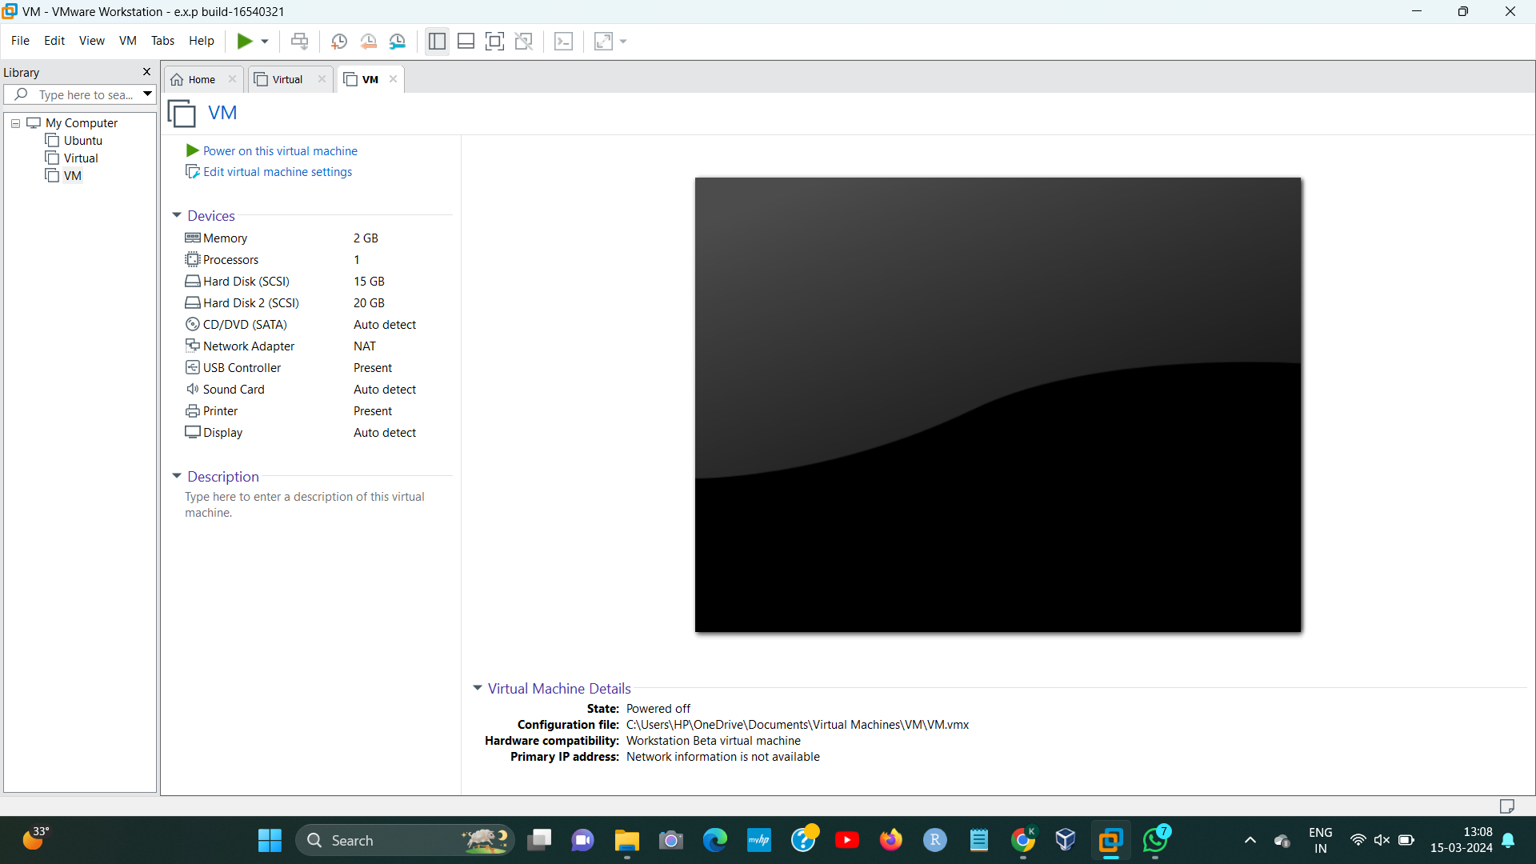[1]

1. 192224191 L.Kalyani